Note: This tutorial is for Github Enterprise with personal account NOT Enterprise with Managed user (EMU). There are two options. In this tutorial we will prioritize the first option. (if you don't have an existing IDP (E.g. Microsoft Entra ID).

Please head to: https://github.com/account/enterprises/new to create a new enterprise account.

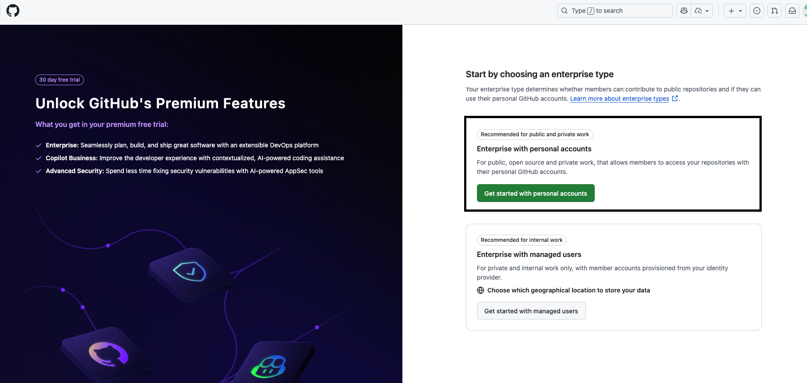

Continue filling the form with your enterprise information.
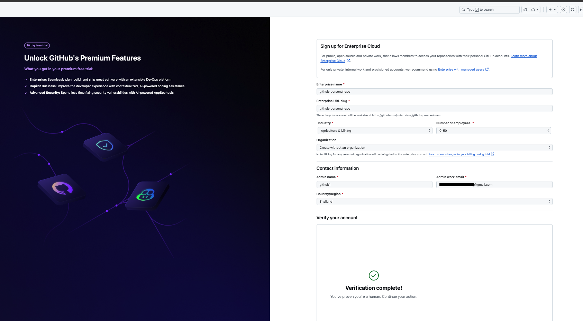

Importantly here, select the payment method -> Add Azure subscription
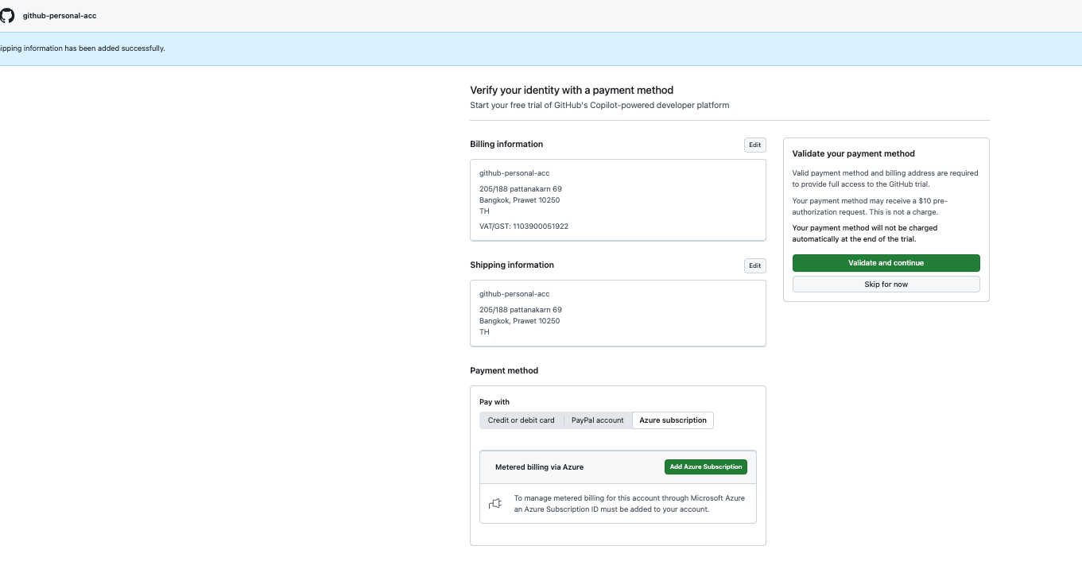

Sign in with your azure account with azure subscription & github enterprise with your azure subscription
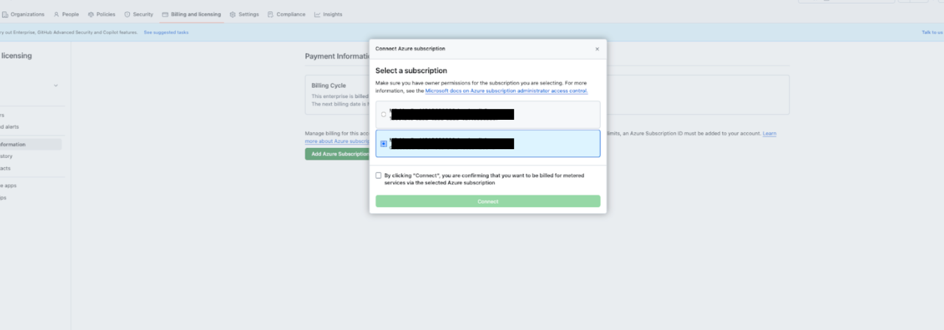
You can continue with the remaining part of the form. Next, inside an enterprise, you can have many organizations. Let's create one.
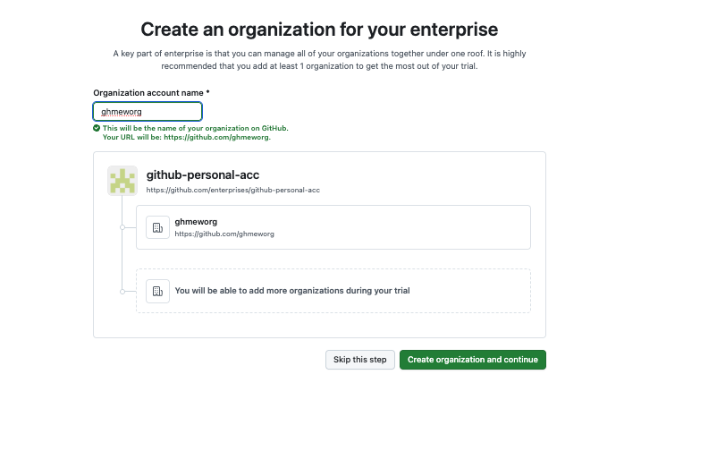

Now, you should see a popup saying “Activate paid Enterprise”. Please ensure you activate the enterprise license
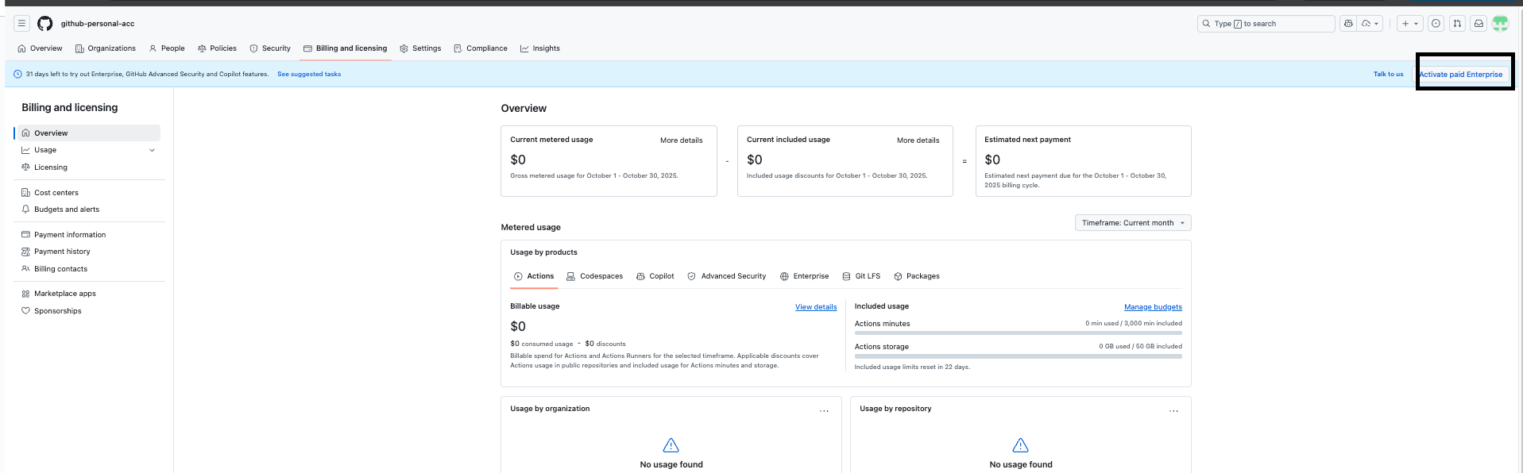
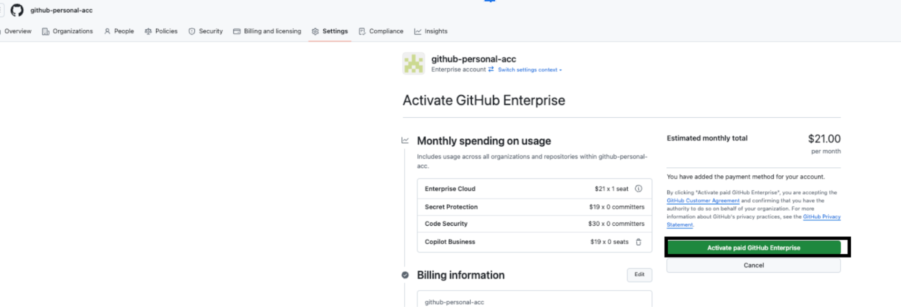
When you are done, you can view the license page to see the number of consumed licenses. See here:https://github.com/enterprises/{org_name}/enterprise_licensing
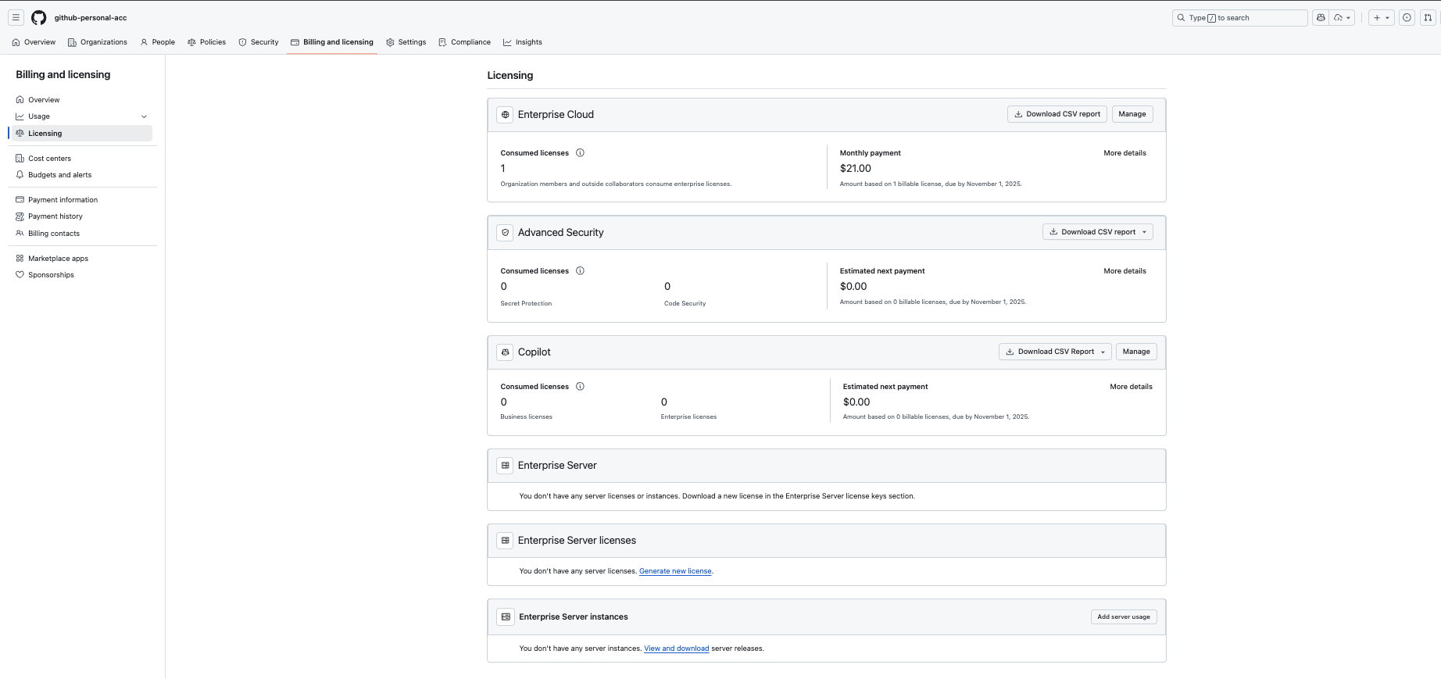
The number of consumed licenses will depend on the maximum number of unique users added to all the organizations.

END

